1. Façade Pattern (Structural Patterns)

The Façade Pattern helps establish some boundaries in what usually is associated with creating a new user. When a person registers to become a Yiptinni Co. Customer, they are assigned somethings from their input in the registration process. The system creates an Account Number for every user that is randomly generated. The system creates a Profile Page that is automatically generated from the input after following registration steps. After providing pet details (and even a photo), the system generates recommendations for your pet scattered throughout different parts of the site (ads, home page, product recommendations, etc.). This is not a concrete component for every user since if someone doesn’t provide information about their pet they will just receive general recommendations.

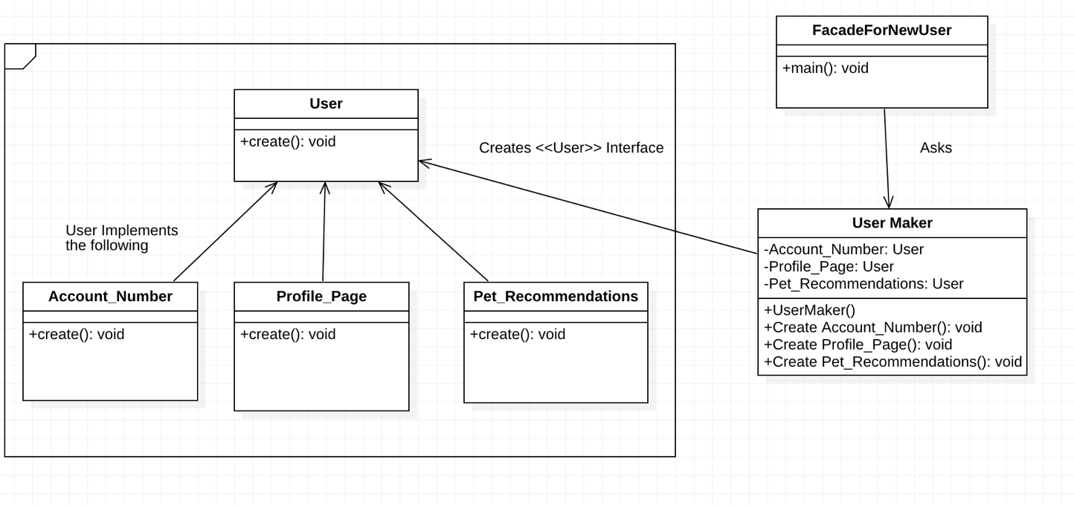

1. Multiple Displays (Observe Pattern)

This pattern will be used when data and an objects state need to be reused in different presentations. The example below shows that the pets name and picture are used in multiple places on the site. Once on the dog information page and the other on the pet page that is used to help find products that fits the animal. This pattern can be useful for other objects as well. For instance, the address of the user in their account and then shown in a different way for auto filling in the checkout process.

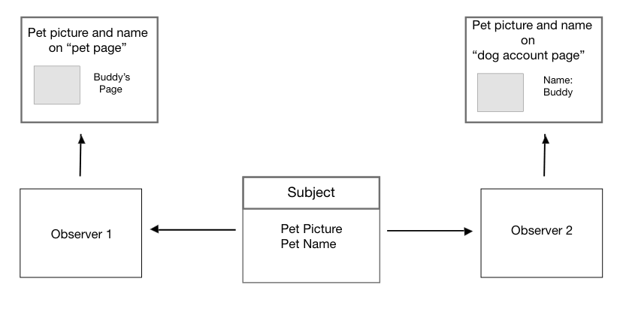

1. Strategy

The strategy design pattern’s goal is to simplify/give a better understanding for when certain algorithms must be used. The diagram below demonstrates how the Strategy design can help us with our code. When we need to use our pet photo algorithm, we need to designate what algorithm to use. For example, we cannot use a dog product finding algorithm with a cat and vice versa. Instead of having the code encompasses all algorithms in a mess, we allocate different sections for different levels for each algorithm. Therefore, the strategy design pattern would help our website.

